

Academic Grading

Concepts, objectives, vocabulary and project rubric for each assignment are distributed to students and are posted in Google Classroom. All work is evaluated on these criteria:

* Demonstration of understanding and inclusion of the taught concepts and objectives.
* Demonstrated craftsmanship and technique.
* Completion and a creative solution to the assignment.

**Work that is Incomplete -as defined in Project Rubric will not be graded.**

Course Work

**Projects and course Units:** Mixed mediastill-life, 1-2 point perspective, Graphite and acrylic autobiographical work, Photoshop compositions: surrealism and tessellations.

**Media:** pencil-graphite, colored pencil, acrylic paint, water-color, mixed media, digital, scratch-board.

**Written Assignments:** Rubrics, Self-reflections, Creative writing, Vocabulary pre-post tests. (Students will submit a written self-evaluation at the end of each project. Students will learn vocabulary, and project objectives; becoming comfortable talking about art and seeing themselves as creative, unique individuals.)

Participation & Expectations

1. ***Be Prepared and be Optimistic*:** You are expected to come to class daily, be on time and be enthusiastic and ready to work. Have your art folder, art materials and pencil.
2. ***Follow classroom procedures:***  There are procedures for handling all art materials and for functioning productively and safely in the art room. Watch and learn.
3. ***Actively listen and participate:*** Be quiet and attentive during lessons and demonstrations. Share meaningful thoughts, ideas, and questions.
4. ***Be Respectful:***Respect your peers, all adults, your classroom environment and materials. Show respect for your work and the work of others.
5. ***Be On Task*:** You are expected to be self-motivating and stay on task, working diligently throughout the entire class period.
6. ***Be Accountable*:** You are responsible for clean-up tasks daily, taking care of all art materials and art room. Be aware of deadlines, Turn in work. And, be aware of your art progress and your class grade.
7. ***Be Safe:*** Handle materials carefully! The misuse of tools can seriously jeopardize your safety and the safety of your classmates

*In art, students display to a daily audience, their efforts and abilities. To have students commit to this daily risk taking, the environment must be one of safety, acceptance and honesty. Please adopt these student expectations and review the Thurston student handbook. These procedures and expectations be consistently enforced. The art room also follow’s Thurston’s “12 Non-negotiable Rules”-that were sent home at Jump Start and that are posted outside of the art room.*



**Student Signature_________________________________________________________________________**

**Parent Signature _________________________________________________________________________**

**All Beginning level Art classes have a consumable materials lab cost of $12.00. A letter explaining this cost and the submission of these monies is attached.**

**Student Teacher: Ms. Laura Doede**

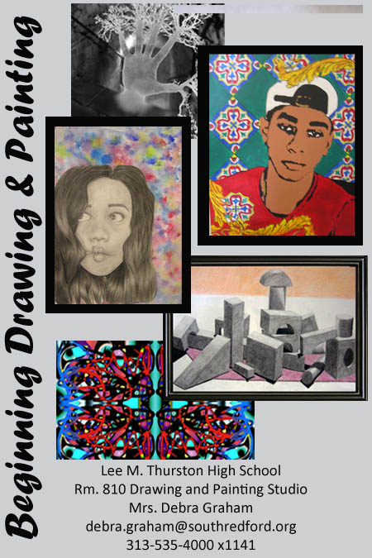

Materials Needed Daily

* Art Folder, pencil pouch, pencils and eraser.
* A Growth Mindset (Ready to work with enthusiasm, focus and purpose!)
* If available: Personal Tablet, phone with access to internet.

***Purses, backpacks and outer wear are not allowed in the art rooms.***

**A little something about your teacher:**

Mrs. Graham grew up in Garden City, MI. She received her Fine Arts and Art Education degrees from MSU and her Master's Degree of Education from the U of M. She is married to Russell. Her 3 children went to South Redford Schools. She has two grandchildren who are wonderful! She has taught Pre-school through 12th grade, Alternative Ed. and college Art Education (WSU). Most of all, she loves teaching art!!!

Course Description and Objectives

# The focus of this course is on the creation of two-dimensional art. Drawings will be created in pencil and colored pencil. Students will explore painting-through watercolor and acrylic paint. Subject matter will range from realistic studies to the imaginative and the abstract. Work by artists past and present will be used to illuminate how artists create and solve problems through visual media. In this course students will practice using design principles in the creation of unified visual statements and they will learn to recognize, reflect and talk about technique, media, and the composition of various works of art. Students will be able to:

* Apply skills and knowledge to perform in the arts.
* Apply skills and knowledge to create in the arts.
* Analyze, describe, and evaluate works of art.
* Understand, analyze, and describe the arts in their historical, social, and cultural contexts.
* Recognize, analyze, and describe connections among the arts; between the arts and other disciplines; between the arts and everyday life.*

Attendance and Deadlines

Almost all work is done in class. It is essential that absences be kept to a minimum. I will not collect your work and materials to send them home if you are ill.

**Projects:** I do not give deadlines for art projects, since each student works creatively at varying speeds. However, after a given amount of time on one project, we move on as a class to the next project. Any unfinished work must be completed in art clinic or at home. If a student demonstrates a pattern of not submitting or finishing work, that student will lose the opportunity to work with art materials and will complete the course with written assignments (see attached student contract).

**Sketch Assignments:** Late sketches are marked late and receive ½ credits. Sketches are the preliminary ideas and layouts needed for the completion of these large projects.

Art Clinic and Advisory

I am after school at least two days every week, you do not need a pass to “drop into” after school art clinic. Just show up. 😊 To

Come to Advisory, you need to ask for a pass from me and have it signed by your Advisory Teacher; this must happen the day before Advisory. Please don’t expect to receive an Advisory pass if you are wasting your time in class or if you have been disruptive. ☹

**\*Michigan Merit Curriculum - Visual, Performing and Applied Arts**

<http://www.michigan.gov/mde/0,4615,7-140-28753_38924_41644_42820---,00.html>

**National Core Arts Standards:** <http://www.nationalartsstandards.org/>